MCTI Foundation Scholarship
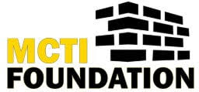

Eligibility: These $500 scholarships are awarded to outstanding MCTI students from each of the four Monroe County sending school districts. The student recipients must be an MCTI program completer and a candidate for Graduation 2026. Applications are due to your MCTI Counselor before April 15. Awards will be presented at MCTI Senior Awards Night.

NAME:

ADDRESS:

PHONE: Email:

SCHOOL DISTRICT:

Essay Requirement: Please answer the following prompts. All answers are to be typed.

- Please explain the passion you have for your program area. (Box will expand as you type.)

- Why do you wish to pursue this field as your future career?

(Hand Signatures Required)
Reviewed and Approved by

MCTI School Counselor
______________________________________Date____________________

Program Instructor
______________________________________Date____________________

MCTI Director
______________________________________Date____________________

Applicant Signature
______________________________________Date__________________

